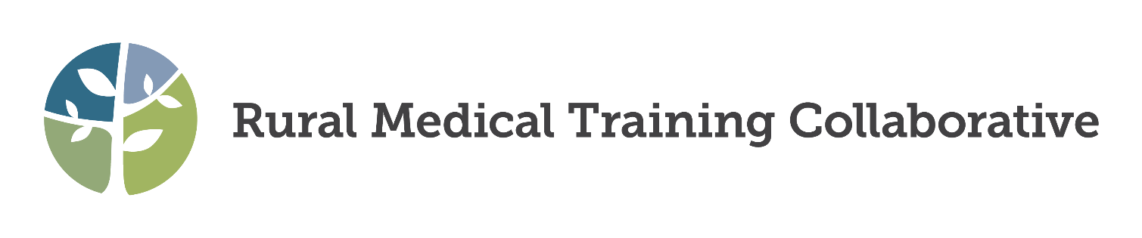The RMTC 2025 Annual Meeting

**Turquoise Trail – The Pathway to Vibrant Rural Healthcare Collaboration**

April 9-11, 2025; Santa Fe, NM

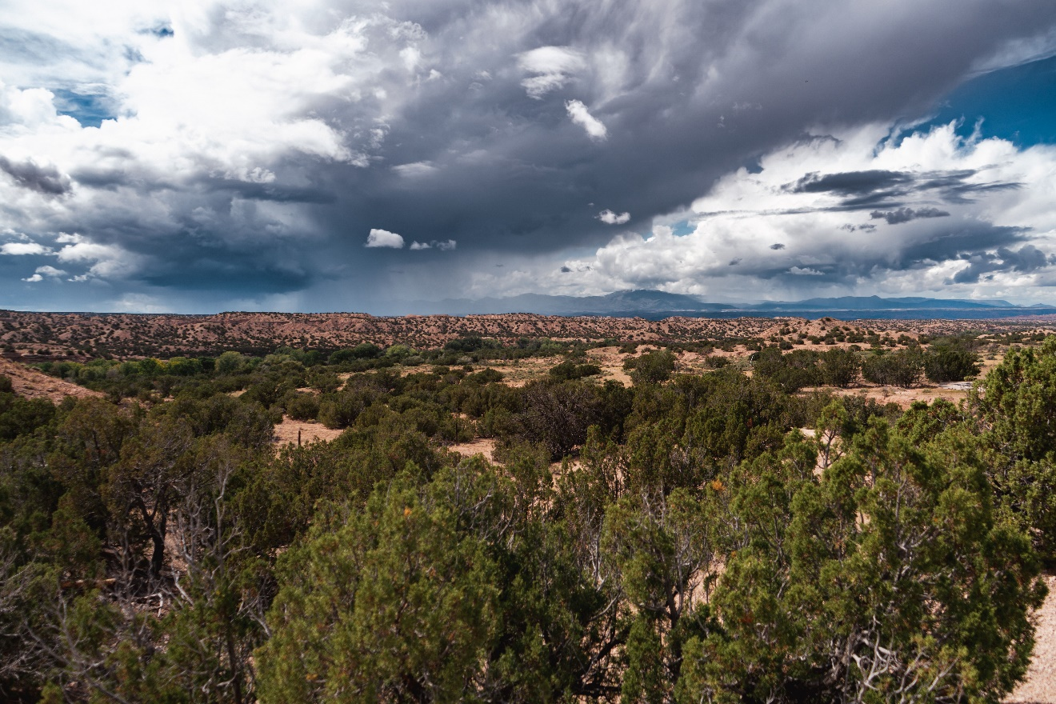

**AGENDA**

(Updated 1/10/25)

|  |  |  |  |  |
| --- | --- | --- | --- | --- |
| **Legend** | | | | |
| Shading | Limited attendance | Plenary | Break | Invited presentations |
| Target Audience | (U): UME | (G): GME | (F): Fellowship | (S): Students |
| (R): Residents | (P): PDs | (A): All | (C): Coordinators |

|  |  |  |  |  |
| --- | --- | --- | --- | --- |
| **Wednesday, April 9:** *Pre-Conference* | | | | |
| 10:15 |  |  |  |  |
|  |  |  |
|  |  |  |
| *11:45* | *Break* |  |  |  |
| 12:00 pm |  |  | RMTC Board of Directors Meeting- |  |
|  |  |
| 1:00 pm | WCGME Coordinators Leadership Institute Workshop – Must be registered for Institute to attend - [Rural GME Coordinators Network — WCRGME](https://nam04.safelinks.protection.outlook.com/?url=https%3A%2F%2Fwww.wcrgme.org%2Frural-gme-coordinators-network&data=05%7C02%7Cjessica.tripp%40mso.umt.edu%7C984a4db60fbe4aed784308dc0d31299c%7C68407ce503da49ffaf0a724be0d37c9d%7C0%7C0%7C638399752008486046%7CUnknown%7CTWFpbGZsb3d8eyJWIjoiMC4wLjAwMDAiLCJQIjoiV2luMzIiLCJBTiI6Ik1haWwiLCJXVCI6Mn0%3D%7C3000%7C%7C%7C&sdata=lcH5rHT2siFUpW3u1hmR43kpmxl7hoPR8e%2BEQWKRV5I%3D&reserved=0) |  |
|  |
| *2:00* | *Break* | *Break* |  |
| 2:15 |  |  |  |
|  |  |  |
| 3:00p |  | RRPDU |  |
|  |  |
|  |  |
|  |  |
|  |  |
| *4:45* | *Break* |  |  |
| 5:00  5:30 | RMTC Meet and Greet? Meet the team | | | |
| *5:45* | *Break* | | | |
| 6:00 | **Welcome and opening plenary-Anthony Fleg** | | | |
| 6:30 |
| 7:00 |
| 7:00 |
| 8:00 |

|  |  |  |  |  |
| --- | --- | --- | --- | --- |
| **Thursday, April 10** | | | | |
| 7:00 am | Breakfast | | | |
| 8:00 am | **Plenary**- Jennifer S Nanez | | | |
| *9:15* | *Break* | | | |
| 9:30  Session 1 | Generational Challenges in Communication  (Gobbo, Hunter) | Bridging the Divide: Transforming Oncology Training to Address the Rural Cancer Gap  (Swenson, Schroeder, Mah, Westergard) | Empowering Future Leaders In Rural Medicine: Rural Health Scholars Program  (Patel, Durfee, Karthik, Pauly)  U, R, S, C | Recruiting Rural – Leveraging Your Mission and Community Strengths  (Shimmens)  G, F, P, C |
| Building Community Resilience: Residency Lessons from Hurricane Helene  (Fralix, Chang, Marburg)  P, R | FARMing Physicians for Rural South Dakota  (Wickersham, Fulk)  U, G, P, S |
| *10:30* | *Break* | | | |
| 10:45  Session 2 | Rural and Tribal Initial Paths for Success: Key Learnings from Getting Programs Off the Ground in Tribal Settings  (Hodge, Toedt, Call, Houser) | Starting Fresh: Using New Leadership Perspectives to Catalyze Innovation  (Stellmon, Armstrong, Bowen) | How to grow a rural FMOB  (Dresang, Landeck, Deutchman)  A | COMPADRE: Bridging UME to GME to Train a Diverse Workforce for Rural, Underserved and Indigenous Communities in California and Oregon  (Trans-Reina, Hollander-Rodriguez, Lupeika, Miller Juve)  U, G, P, C |
| Sustaining Leadership: Succession Strategies for Rural Residency Success (Bowman, Bomengen, Epstein) |
| 11:45 | **Poster Session** (through 12:45) | | | |
| 12:00 pm | **Lunch** | | | |
| *1:15* | *Break* | | | |
| 1:30  Session 3 | Building Community with Community: The Rural and Urban Community Orienting Experience (RUCOE)  (Casapulla, Lingerak)  U, G, F, P | Enhancing Prenatal Care for Migrant Populations Through Collaborative Rural Partnerships  (Batchelor)  G, P, C | Residency Development Enriches Rural Community Practice (Lewis, Latham, Charl)  G, P, C | Didactics in a Rural Training Program - strategies for balancing curriculum, faculty time and collegiality in a 1:2 Program  (Miller, Ton)  G, P, R, C |
| Bridging the Gap: Empowering Rural Healthcare Through Collaborative Innovation  (Rivenbark)  U, G, P, S | Primary Care at the Farm: How to build a farming community-based clinic  (Caviness)  A | **S**imulation Leadership Project  (Rear)  A |
| *2:30* | *Break* | | |  |
| 2:45  Session 4 | Driving Engagement and Growth for Rural Residency Program Recruitment  (Crubel, Yanke)  U, G, P, R, S, C | Investigating Resident Physicians Well-being Initiatives in Rural Residency Programs  (Naslund, Sandroni, Schmitz, Longenecker)  U, G, F, P, R, C | Building Your Rural Residency’s Digital Presence  (Dozal)  U, R, S, C | RTP Design for Future Scope of Practice--How to give them what they need?  (Smith, Reed, Ware, Moore)  G, F, P |
| Rural Recruitment and a Successful Match  (McMenomey)  G, P, C | One week at a time - Creating a longitudinal block schedule to create joy of continuity of care  (Hall, Thompson, Younes) |
| *3:45* | *Break* | | |  |
| 4:00  Session 5 | Utilizing online resources to expand educational opportunities  (Gregg, Wolfe-Meyer)  R, C | Breaking trail in Rural GME: The UW Alaska Rural Track Program in Internal Medicine  (Hearing, Pokorney)  G, P | Model for Effective Procedural Care Education for Resident Physicians Training in Rural New Mexico  (Duncan)  G, R | Integrating Community-Led Cultural Safety into Rural Training  (Babcock, Bellon, Stiffarm, Bell)  A |
| Innovations in Training and Practice – GME Consortium Model  (Chavez, Benton)  U, G, P, C | Frontier Surgery - The Case for Dual Boarding in Surgery and Rural Family Medicine  (Kermode) | Improving Home Visits through Community Partnerships  (Langa, Caldwell, Denney)  G, P, R |
| 5:00 | Dinner / Evening on own | | | Student / Resident Reception (**R, S)** |
| 6:00 |

|  |  |  |  |  |  |
| --- | --- | --- | --- | --- | --- |
| **Friday, April 11** | | | | | |
| 7:00 am | Breakfast | | | | |
| 8:00 | Plenary: TBD | | | | |
| *8:45* | *Break* | *Break* | | *Break* | *Break* |
| 9:00 | NIPPD Presentations (9:00a-10:00a) | How to Prepare for an ACGME Site Visit (Bergeson) | |
| 9:30 Session 6 | Panel Discussion  Stages of GME Leadership: From Idealism to Sustainability  (Gobbo, Caylor, Clements, Montgomery)  G, F, P | | Approaches to Faculty Development Among New Residency Programs (Brown, Evans, Gookin, Weidner)  G, F, P | **2-hour session:**  Arizona Trails and Rivers: Mapping the Path to Workforce Development  (Hunt, Cartsonis, Dolasa, Castañeda)    Cont. from above |
|  | Data Dashboard: Keeping Up with the New Family Medicine Requirements  (White)  G, P, C | Cultivating Collaboration: A New Method for Faculty Development via Book Clubs  (Worczak)  U, G, P, C |
| *10:30* | *Break* | | |  |
| 10:45  Session 7 | Building Community Voice: The Rez Café Model for Engaging Patients Through World Café Discussions  (Couldridge, Muller) | Overcoming Financial Challenges in Sustaining Rural Residency Programs: Lessons Learned from the Rural Residency Planning and Development Program (Steele, Pauwels, Scott)  G, P, C | | Navigating Change: The Evolution of Our Interview Process from In-Person to Virtual and Back Again—Success Through Standardization and Innovation with Thalamus"  (Worczak, Lacey)  G, P, C |
| 11:45 | *Break* | | | | |
| 12:00 pm | **Conference on the Move #1:** | |  | | |
| 1:00 |
| 2:00 |
| 3:00 |
| 4:00 |
| 5:00 |
| 6:00 |